**Java Web开发**

**实验七**

**作业报告**

|  |  |
| --- | --- |
| 学 院 | 计算机学院 |
| 所在系 班 级 | 2017软件工程系7班 |
| 学 号 姓 名 | 04171512高健峰 |
| 指 导 教 师 | 郭晓燕 |
| 完 成 时 间 | 4.10 |

# 实验题目

1. 1、页面输入收入，得到相应的缴纳税收
2. 要求：Jsp提交收入，显示结果（可一个页面也可两个页面）。编写一个JavaBean计算税收，并在JSP页面输出结果
3. 计算方法：全月应纳税所得额＝月收入－1600元
4. 级数 全月应纳税所得额 税率% 速算扣除法(元) 1 dr <=500 5 0
5. 2 500 <dr<=3000 10 25
6. 3 3000 < dr <=5000 15 125
7. 4 5000 < dr <=20000 20 375
8. 5 20,000 < dr <=40000 25 1375
9. 6 40,000 < dr <=60,000 30 3375
10. 7 60,000 < dr <=80,000 35 6375 8 80,000 < dr <=100,000 40 10375 9 dr >100,000元 45 15375
11. 如：月收入3000，则（3000-1600）*10%-25=115，因为3000-1600大于500小于2000，所以按10%计算后再扣除速算的部分

**关键源码（部分）**

## <%@ page language=*"java"* import=*"java.util.*"* pageEncoding=*"UTF-8"*%>

## <%

## String path = request.getContextPath();

## String basePath = request.getScheme()+"://"+request.getServerName()+":"+request.getServerPort()+path+"/";

## %>

## <!DOCTYPE HTML PUBLIC "-//W3C//DTD HTML 4.01 Transitional//EN">

## <html>

## <head>

## <base href=*"*<%=basePath%>*"*>

## 

## <title>My JSP 'MyJsp.jsp' starting page</title>

## 

## <meta http-equiv=*"pragma"* content=*"no-cache"*>

## <meta http-equiv=*"cache-control"* content=*"no-cache"*>

## <meta http-equiv=*"expires"* content=*"0"*>

## <meta http-equiv=*"keywords"* content=*"keyword1,keyword2,keyword3"*>

## <meta http-equiv=*"description"* content=*"This is my page"*>

## <!--

## <link rel="stylesheet" type="text/css" href="styles.css">

## --

## </head>

## <body>

## <form action=*"Servlet.java"* method=*"post"*>

## 收入<input type=*"text"* name=*"uname"*></br>

## <input type=*"submit"* value=*"提交"*>

## </form>

## </body>

## </html>

## <%@ page language=*"java"* import=*"java.util.*"* pageEncoding=*"UTF-8"*%>

## <%

## String path = request.getContextPath();

## String basePath = request.getScheme()+"://"+request.getServerName()+":"+request.getServerPort()+path+"/";

## %>

## <!DOCTYPE HTML PUBLIC "-//W3C//DTD HTML 4.01 Transitional//EN">

## <html>

## <head>

## <base href=*"*<%=basePath%>*"*>

## 

## <title>My JSP 'Welcome.jsp' starting page</title>

## 

## <meta http-equiv=*"pragma"* content=*"no-cache"*>

## <meta http-equiv=*"cache-control"* content=*"no-cache"*>

## <meta http-equiv=*"expires"* content=*"0"*>

## <meta http-equiv=*"keywords"* content=*"keyword1,keyword2,keyword3"*>

## <meta http-equiv=*"description"* content=*"This is my page"*>

## <!--

## <link rel="stylesheet" type="text/css" href="styles.css">

## -->

## </head>

## <body>

## 收入:<%=request.getAttribute("name") %></br>

## 缴税:<%=request.getAttribute("i")%>

## </body>

## </html>

**package** _1;

**import** java.io.IOException;

**import** java.io.PrintWriter;

**import** javax.servlet.ServletException;

**import** javax.servlet.annotation.WebServlet;

**import** javax.servlet.http.HttpServlet;

**import** javax.servlet.http.HttpServletRequest;

**import** javax.servlet.http.HttpServletResponse;

//@WebServlet(name="11", urlPatterns="/hello")

**public** **class** Servlet **extends** HttpServlet {

**protected** **void** doGet(HttpServletRequest request, HttpServletResponse response)

**throws** ServletException, IOException {

request.setCharacterEncoding("utf-8");

Double name=Double.*parseDouble*(request.getParameter("uname"));

Date date=**new** Date(name);

**double** i=Value.*value*(date);

request.setAttribute("i",i);

request.setAttribute("name",name);

request.getRequestDispatcher("Welcome.jsp").forward(request,response);

}

**protected** **void** doPost(HttpServletRequest request, HttpServletResponse response)

**throws** ServletException, IOException {

**this**.doGet(request, response);

}

}

**package** _1;

**public** **class** Value{

**public** **static** **double** value(Date date){

**double** i;

**double** d=date.getDate();

**double** dr=d-1600;

**if**(dr>0&&dr<500){

i=dr*0.05;

}**else** **if**(dr>500&&dr<=3000){

i=dr*0.1-25;

}**else** **if**(dr>3000&&dr<=5000){

i=dr*0.15-125;

}**else** **if**(dr>5000&&dr<=20000){

i=dr*0.2-375;

}**else** **if**(dr>20000&&dr<=40000){

i=dr*0.25-1375;

}**else** **if**(dr>40000&&dr<=60000){

i=dr*0.3-3375;

}**else** **if**(dr>60000&&dr<=80000){

i=dr*0.35-6375;

}**else** **if**(dr>80000&&dr<=100000){

i=dr*0.4-10375;

}**else** **if**(dr>100000){

i=dr*0.45-15375;

}**else**{

i=0;

}

**return** i;

}

}

**package** _1;

**public** **class** Date{

**private** **double** date;

**public** Date(Double name){

**this**.date=name;

}

**public** **double** getDate(){

**return** date;

}

**public** **void** setDate(**double** date){

**this**.date=date;

}

}

# 运行效果图

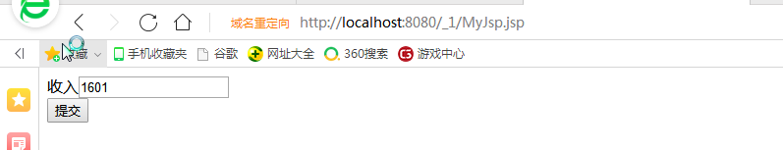

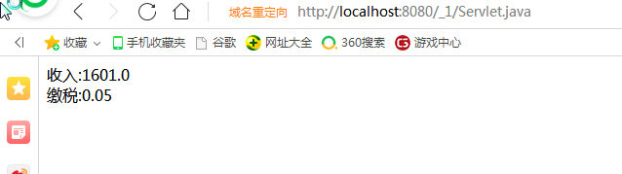

# 收获与问题

有点意思。。